Chess game test plan:

- Basic Functions
  - Start the program. Start up should look like this.
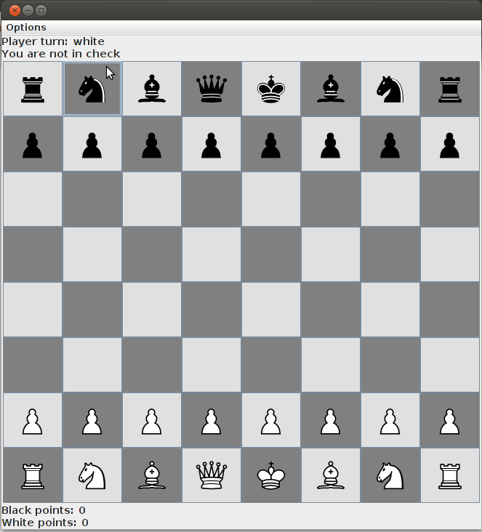
    - Try and moves pieces. Be aware of the top label where it displays whose turn it is.
    - If it is not your piece, you should not be allowed to click it.
    - If it is your piece, the tile should be highlighted in yellow.
    - If you try to move a piece and the move is invalid, a pop up box should appear
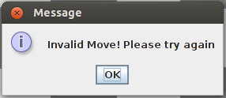

    - Check and Check Mate
      - Put a king into check. You should notice the top label is now set to saying the current player is in check. You should also notice that any move you attempt to make that does not resolve the check is rendered invalid.

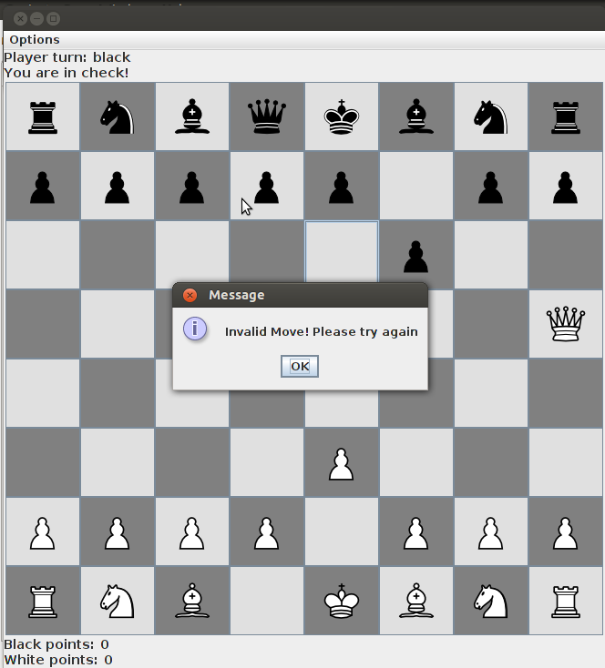
Black is in check, and it is displayed that it is black's turn and he is in check. After trying to move a black pawn that would not put its own king out of check, the invalid move pop up is displayed as the player must resolve the check

      - Move the pieces to a check mate configuration. You should see a pop up saying there is a check mate in effect, and who the winner of the game is. After clicking OK, please note that the point system on the bottom of the interface has incremented.

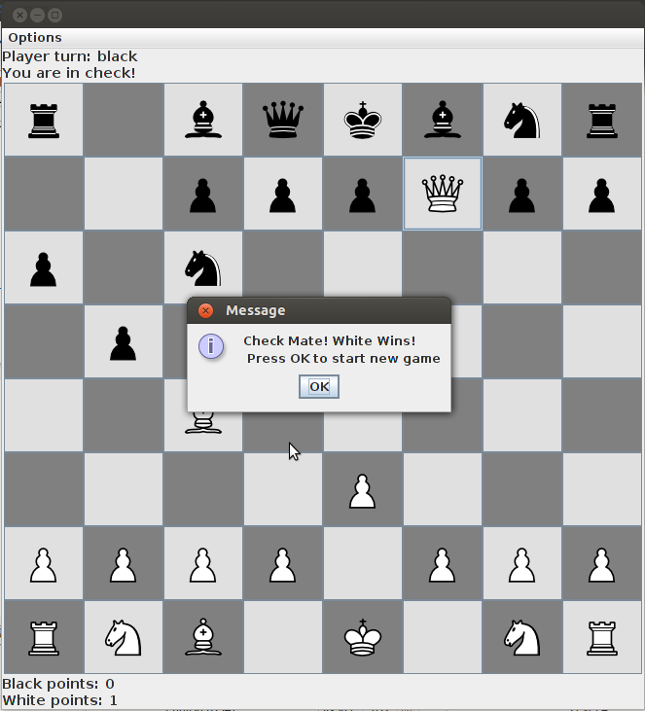

2. After pressing OK, the board should automatically reset itself to the beginning state, allowing a new game to be immediately played,

- Restart Game
  - Click on the Options tab on the top area of the UI. Then click restart game. This should automatically reset the board to the beginning state, with white going first. The point system on the bottom of the UI should not be changed.
4. Undo Button
1. Clicking the undo button under the Options tab will undo the last move. Repeatedly clicking will continuously undo moves. The player turn will update every undo, and so will the check label. If an undo move puts a player in check, this will be displayed

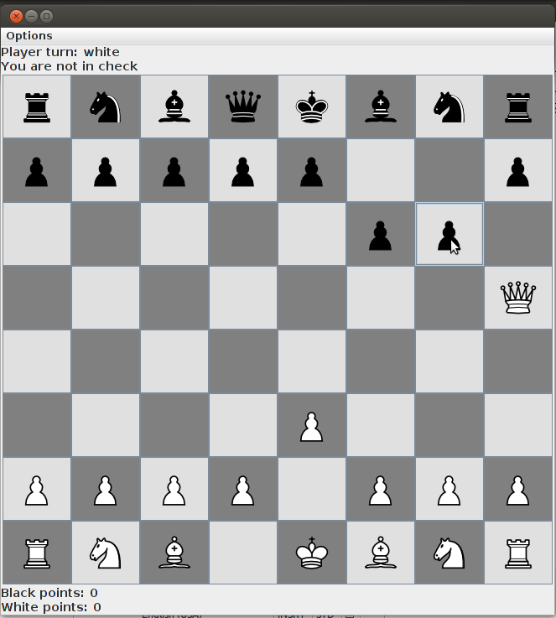
Then press Undo button

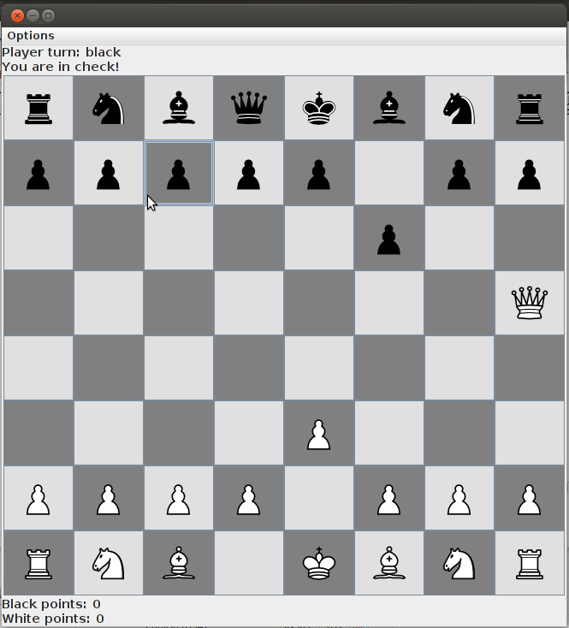
The black pawn move was undone, the black side is in check once again as shown by the check label on top of the game, and it is again blacks turn. Undo can be continuously pressed until board is set back to start stage. Pressing Undo again:

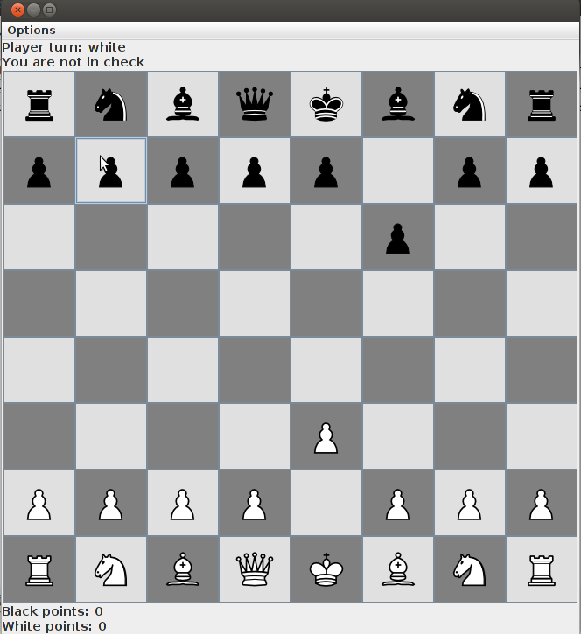
The white queen's last move has been undone, and the move is back to white

- Forfeit Game
  - In the options menu, click the forfeit game button. A pop up will appear asking the other player if he/she accepts the forfeit. If the other player accepts the forfeit, the game is set back to the initial state, and the player accepted the forfeit gains a point in the point system on the bottom of the UI

